

|  |  |  |  |  |  |  |  |  |
| --- | --- | --- | --- | --- | --- | --- | --- | --- |
|  | | | | | | | | |
|  | | CSLR 51 : DBMS LAB-10 | | | | |  | |
|  |  | | | | | | |  |
|  | | | |  |  | | | |
|  | | | | Roll no. : 106119100Name : Rajneesh PandeySection : CSE-B |  | | | |
|  | | |  | | |  | | |

-- Create database EMP and Make Collection With name "EMPL" and Follow Queries

--Created Database

 use emp

 switched to DB emp

Database created :

--Create Collection

 db.createCollection("empl")

--Insert Records Into EMPL Collection

 db.empl.insert([

 {no:1,name:"ST",salary:2000,role:"OB"},

 {no:2,name:"MSD",salary:1500,role:"WK"},

 {no:3,name:"YS",salary:1000,role:"ALR"},

 {no:4,name:"RD",salary:1000,role:"MOB"},

 {no:5,name:"RS",salary:500,role:"OB"},

 {no:6,name:"BK",salary:500,role:"MOB"},

 {no:7,name:"VK",salary:300,role:"BW"},

 {no:8,name:"JB",salary:400,role:"BW"},

 {no:9,name:"HP",salary:400,role:"ALR"},

 {no:10,name:"VS",salary:300,role:"OB"}])

--Display Data in Proper Format

db.empl.find().pretty()

--Update Salary Of Employee where Name is "ST" by +8000

db.empl.update({name:"ST"},{$inc:{salary:8000}})



--Update Salary Of All Employee by giving an increment of +4000 each

db.empl.update({},{$inc:{salary:4000}},{multi:true})

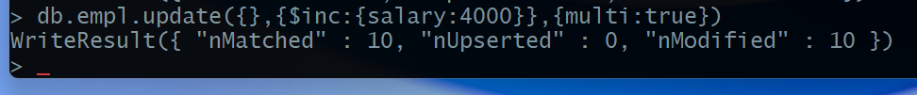

--update role of "MSD" as "C and WK"

db.empl.update({name:"MSD"},{$set:{role:"c and WK"}})

--Add a New Field remark to document with name "RS" set Remark as WC

db.empl.update({name:"RS"},{$set:{remark:"WC"}})

--Add a New Field As Number 11,name AK,Salary 10000,role coach without using insert statement. But for Doing So You should have a Record Added with number 11.

db.empl.update({no:11},{$set:{no:11,name:"AK",salary:10000,role:"coach"}},{upsert:true})

--remove added New Field

db.empl.update({name:"RS"},{$unset:{remark:"WC"}})

--Update the Field "RD" by multiplying with salary by 2

db.empl.update({name:"RD"},{$mul:{salary:2}})

--To Find Document From the empl collection where name begins with S

db.empl.find({name:/^S/})

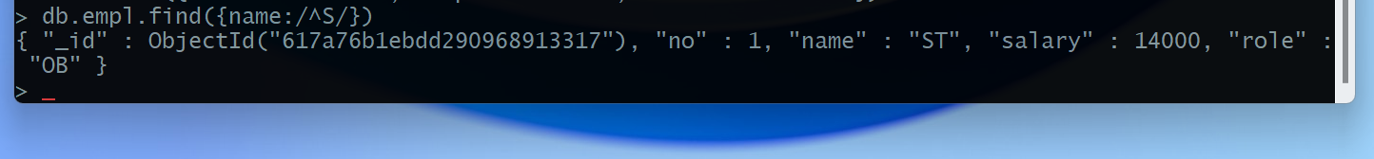

Database After all the query

